Module 3
Create a table orders with order id, order date, amount, customer id

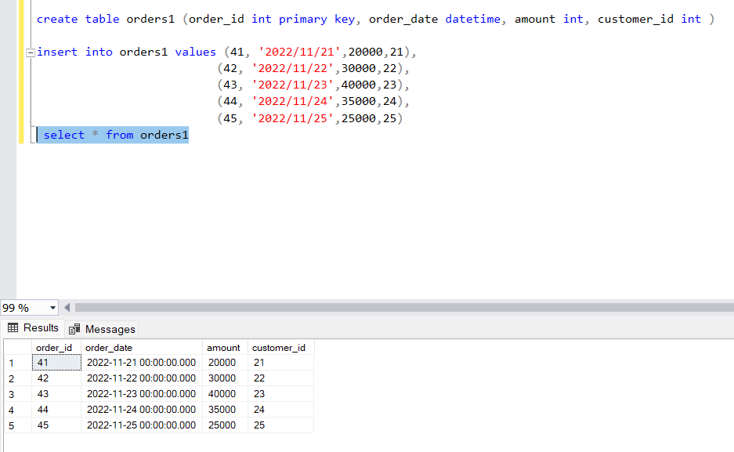

Module 3
Inner join tables customer and orders for column customer id

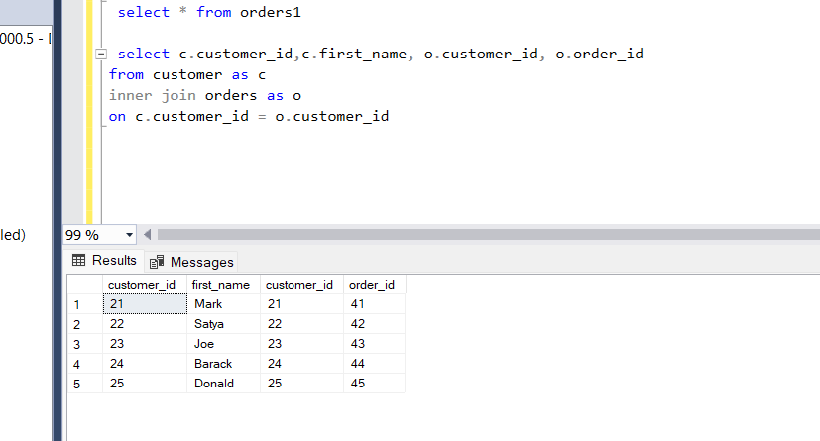

Module 3
Left Join

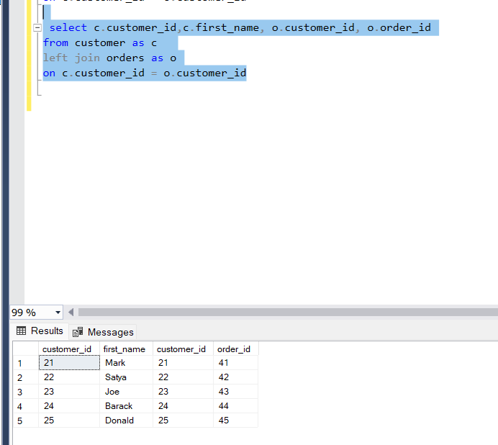

\

Module 3
Right Join

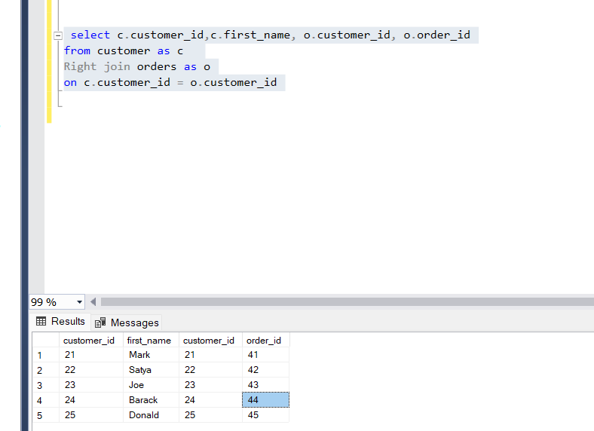

Module 3
Update orders table, set amount = 100 where customer id is 43:

